Learning Journal Unit 2

An Assignment submitted in partial fulfillment of the requirements for the degree of
Bachelor of Science
in
Computer Science

ENVS 1301: Introduction to Environmental Sciences
Term 3 - 2025
University of The People
February 13, 2024

Learning Journal Unit 2
Go to the EPA website and learn about “Reduce, Reuse, Recycle”
- Are any of these options and/or types of programs available in YOUR local community/village/town? Which ones? Explain.
We have recycling though conducted in an informal way where you would often see people walking around collecting scrap metals to go and sell to the industries in the informal sector, often known as “Jua kali” in Kenya.
- What about in your home? Explain.
At home I use composting where I have dug a hole at one corner in my homestead where we throw food wastes and later reuse as compost manure in the farm.
- If none are used in your local town or home, which could be? Explain.
Given a chance to formalize “Reduce, Reduce, Recycle” program in my community, I would start with recycling due to its several benefits already witnessed in the United States as published by the US Environmental Protection Agency (EPA). At environmental level, recycling conserves natural resources by reducing the need to extract raw materials (EPA, 2024). It helps combat climate change, with EPA data showing that recycling and composting saved over 193 million metric tons of carbon dioxide equivalent in 2018 (EPA, 2024). Energy savings are significant; for example, recycling just 10 plastic bottles can power a laptop for more than 25 hours (EPA, 2024). Moreover, recycling reduces waste and pollution by diverting materials from landfills and incinerators (EPA, 2024).
Looking at economic benefits, recycling industry creates jobs. In a single year, recycling and reuse activities in the U.S. accounted for 681,000 jobs (EPA, 2024). Alluding to its informal recycling already taking place, those collecting the waste materials to go and sale use it as a means of livelihood. Therefore, by formalizing it, it will even create job opportunities to many people. EPA (2024) notes that recycling generates wages, with $37.8 billion in wages attributed to recycling activities. In addition, recycling contributes to US government tax revenue, generating $5.5 billion in a year (EPA, 2024).
Finally, at community level, implementing recycling provides a healthier and more sustainable alternative to waste management facilities, which are often concentrated in underserved communities (EPA, 2024). Moreover, it can help address environmental justice issues by reducing negative impacts on human health, property values, and land productivity in these areas (EPA, 2024).
Having noted the benefits of recycling in threefold, let me give a summary of how it can be implemented in my community. I will start by establishing collection methods such as curbside collection or drop-off centers (EPA, 2024). Second, I will focus on educating the community about what can be recycled and how to properly sort materials. Third, encouraging the purchase of products made from recycled materials to close the recycling loop (EPA, 2024). Finally, partnering with local businesses to promote recycling and the use of recycled content in products. It is worth mentioning that by implementing recycling, my community will be able to contribute to environmental protection, economic growth, and social equity while being part of a larger national effort to improve waste management and resource conservation.
- Please outline in your own words, one new thing you learned this week in the course. How does it apply to your life?
Biodiversity hotspot. Growing up in my rural home where there different species of bananas we plant, I have noticed nowadays there is one species of banana becoming rare to find since we really enjoyed it during out childhood. The reason behind its scarcity today is having low market value which have made farmers to ignore while some uproot its suckers from the farm. However, there is one thing they are forgetting, that species of banana was a food we could easily get at after coming from the farm and you are tired. The fact that no one would bother to take to the market made it an advantage to those who need it as a source of nutrient. So, one thing I have learnt it to try save endangered species regardless of their monetary value. To practice this, I am going to look for this banana species I am talking about to go and plant it my farm to conserve it. In fact, they are three banana species I am talking about, see photo references below, those are local names. I do not know their scientific names, but I believe with the photos you can relate if you have same banana species in your community. I do not know if they are endangered species in your community as well.
 | Odhigo jowuoro | Okwaro | Bogobogo
Image | 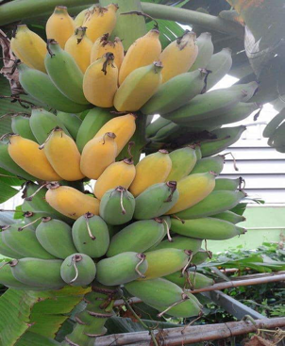 | 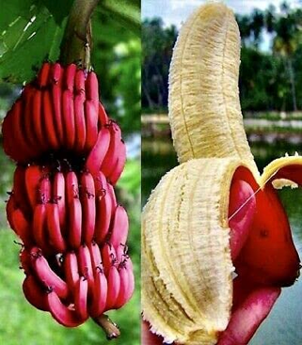 | 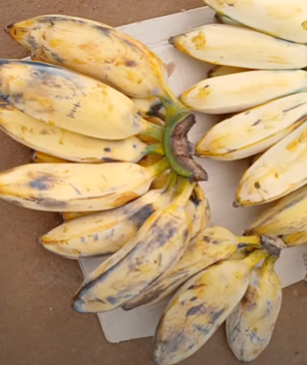
Description | Have green peel which turn yellow when ripe. | Have red peel and eaten when ripe. | Often confused with plantain. However, they are cooked when ripe.
Source | https://www.facebook.com/photo.php?fbid=997688320813989&id=288877565028405&set=a.288894358360059 | https://www.ubuy.co.th/th/product/4SUKA07V2-red-banana-sanzibar-musa-acuminata-exotic-tropical-pups-or-tissue-cultures | https://www.youtube.com/watch?v=RhfyVuhoxF0

- Tell me, the professor, how this course is going for you so far? How do you find the material?
All is going well so far as I learn new things I did not cover when learning same course before such as biodiversity hotspot. I think it is starting to get interesting.

References
EPA. (2023, November 27). Recycling basics and benefits. US EPA. https://www.epa.gov/recycle/recycling-basics-and-benefits

